Quiz – Biomes and Adaptations

- Which biome has four seasons and broadleaf trees that lose their leaves in the fall? (*)
  - Tropical Rainforest
  - Tundra
  - Deciduous Forest
  - Taiga

- Which of the following descriptions best describes the tropical rainforest? (DOK 2) (*)
  - The biome has soil that is very dry and low in nutrients and organic matter. It has lots of sand and does not hold water very well.
  - There is high biodiversity (lots of different types of plants and animals), plentiful rain, and year-round warm temperatures.
  - The biome has very long harsh winters with little sunlight, year-round frozen permafrost under the soil, and a very short growing season.
  - The biome is very rich in nutrients because of the decomposition of grass during the winter or dry season.

- Which of the following describes plant life in a temperate deciduous forest? (DOK 2)
  - Evergreen trees with needles
  - Cacti with waxy exteriors and sharp needles
  - Kelp beds
  - Trees whose leaves change color and fall off in the autumn

- Which of the following characterizes (describes) the taiga’s plant life? (DOK 2)
  - Trees whose leaves change color and fall off in autumn
  - Cacti with waxy exteriors and sharp needles
  - Evergreen trees with needles
  - Canopied trees requiring much rainfall each year

- Which of the following biomes receives little rainfall and is home to organisms such as cacti, lizards, and scorpions?
  - Taiga
  - Tundra
  - Desert
  - Temperate Deciduous Forest

- Which of the following descriptions best describes the tundra? (DOK 2)
  - There are very few different animals and plants that live in the rainforest.
  - The desert receives the most rainfall out of the biomes.
  - Trees that have needle-like leaves which remain year-round.
  - A climate whose temperatures are often below freezing.

- Vultures have big eyes to allow them to see better at night. Because they can hunt at night, they can avoid the really high temperatures of their home. What biome is the vulture best adapted to live in?
  - Taiga
  - Tundra
  - Desert
  - Temperate Deciduous Forest

- Which of the following would be the best adaptation for an animal living in the tropical rainforest? (DOK 2)
  - Many layers of fat and fur
  - Short fur
  - A tail for climbing trees
  - Bright colored feathers

- Which of these is an adaptation that desert animals would MOST LIKELY develop in response to high temperatures found in the desert? (DOK 2)
  - They hibernate in the winter.
  - They are awake at night and sleep in the day.
  - They lay eggs that must incubate in water.
  - They have very dark fur and skin.

- Egypt is a country located in Northern Africa. It receives very little rain, is hot in the day, and is cold at night. In which biome is Egypt located? (DOK 2)
  - Temperate deciduous forest
  - Tropical rainforest
  - Taiga
  - Desert

- Puffins breed in holes they dig into the ground and build their nests. By building into the ground, they get a bit more protection from the harsh cold weather. What biome is the puffins best adapted to live in?
  - Taiga
  - Tundra
  - Desert
  - Temperate Deciduous Forest

- Orchids are a beautiful, abundant flowering plant. They grow best in a very humid environment with plenty of water. What biome is the orchid best adapted to live in?
  - Taiga
  - Tundra
  - Desert
  - Tropical Rainforest

- Which of these correctly describes an omnivore and gives an example of how it obtains nutrients for survival?
- Oak tree; adaptations allow it to obtain nutrients from the sunlight.
- Cow; adaptations allow it to obtain nutrients from only producers.
- Human; adaptations allow it to obtain nutrients from producers and consumers.
- Mushroom; adaptations allow it to obtain nutrients from once living organisms.

- An organism is shown in the picture to the right. Which of the following terms accurately classifies this organism?
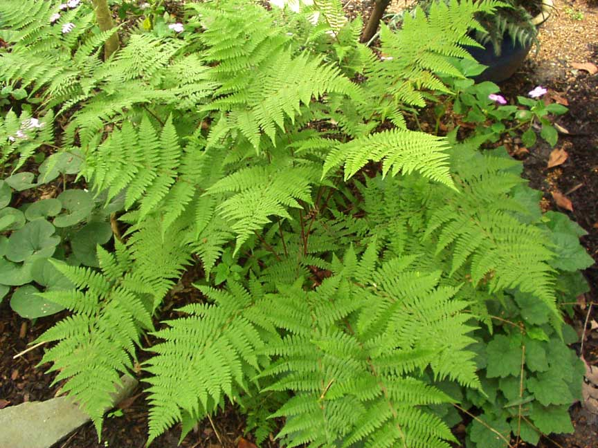
      - Herbivore
      - Consumer
      - Decomposer
      - Producer

- A member of the 2017 graduating class from Shaw went on to become a biological scientist and explorer. Deep in the tropical rainforest of South America she discovered a new species of frog. She observes this frog has a variable diet, feeding on flies, butterfly eggs, leaves, and moss. Which of the following terms most accurately describes this frog?
      - Herbivore
      - Carnivore
      - Omnivore
      - Decomposer

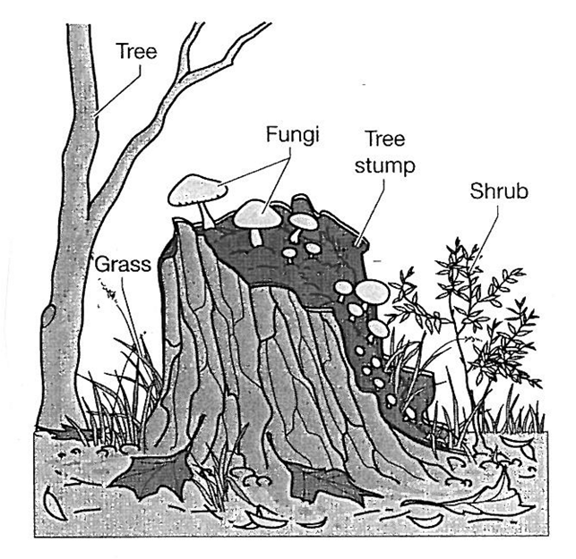
16. The fungi shown in the picture to the right are decomposers. Why are decomposers an important part of an ecosystem?
- They produce oxygen, a nutrient used for cellular respiration.
- They provide nutrients for carnivores.
- They break down dead organisms and return the nutrients to the soil.
- They convert sunlight into nutrients for plant life.

17. Zebras, lions, and grass and three organisms that can be found in the Savannah (grassland in Africa). Zebras eat the grass and lions eat the zebras. Based on this information, choose the TWO statements below that are true.
      - Zebras are producers
      - Zebras are decomposers
      - Grass is a heterotroph
      - Grass is an autotroph
      - Lions are herbivores
      - Lions are carnivores

