Key Points on Pangea:

1. 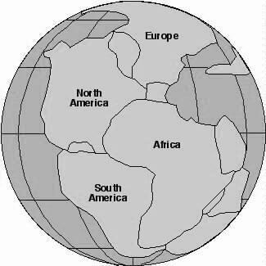The crust is divided into different pieces called **tectonic** **plates**.
2. These plates **move** over time, but they move very **slowly**.
   1. The plates only move a few **centimeters** each year.
3. These plates move because of the **convection** **currents** in the **mantle.**
   1. As molten rock rises from the core, cools and sinks it **pushes** the plates.
4. Since continents are part of the plates, as the plates move, the **continents** move.
5. 200 million years ago, all of the continents were once next to each other and formed a “**supercontinent**.” This supercontinent is called **Pangea**.
6. Two pieces of evidence tell us the continents once fit together.
   1. The continents fit together like **puzzle** **pieces**.
   2. Identical plant and animal **fossils** of the same age have been found in rocks in Africa and South America. This means that the same plants and animals lived in these two places millions of years ago.

Key Points on Divergent Boundaries:

1. 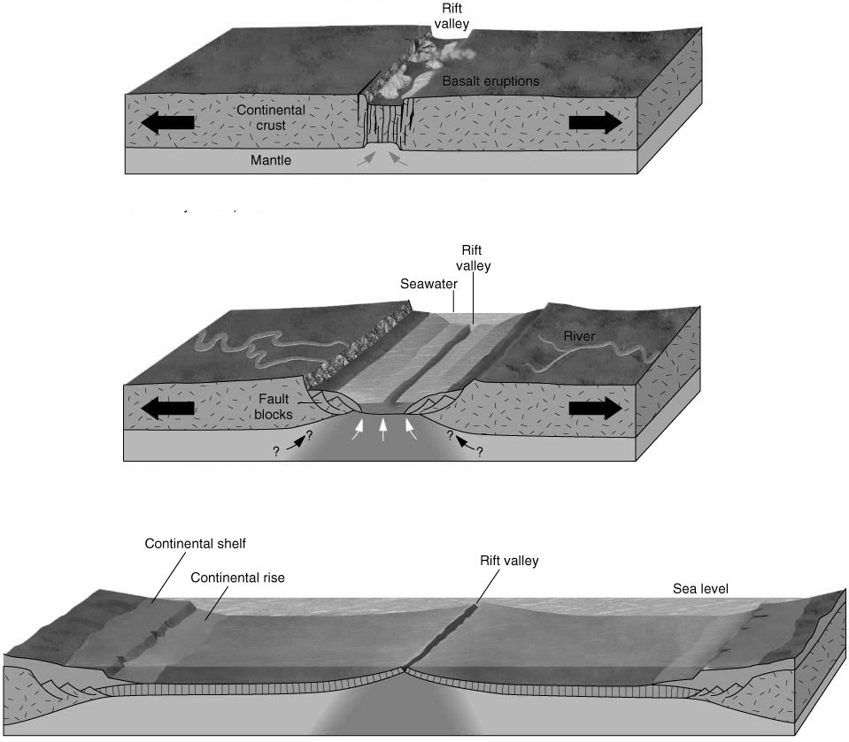**Divergent** **Boundaries**: where two tectonic plates are **moving** **away** from one another
   1. These can form on the **seafloor** or on a **continent**
2. When a divergent boundary is found on **land**, a **rift** is formed.
   1. A rift is a place where the land begins to **sink**.
   2. Over millions of years the rift will sink so low that it fills with **water** and will eventually become an **ocean**.
3. When a divergent boundary forms underwater, a **mid** **ocean** **ridge** forms.
   1. A mid ocean ridge is a long underwater **mountain** system.
   2. As the plates spread apart, **magma** rises and **cools** forming these mountain chains.
4. Divergent boundaries are the source of Earth’s **new** crust.
5. The **newest** crust is directly next to the divergent boundary.
6. The farther the crust is from the boundary, the **older** it is.
7. Divergent boundaries are known for their intense **volcanic** activity
8. Magma (molten rock) **rises** through the Earth’s crust at divergent boundaries
   * 1. Remember, this molten rock cools to form the new **crust**.

**Divergent**

Key Points on Convergent Boundaries:

1. **Boundaries** are the spots were two plates meet
2. **Convergent** **Boundaries**: where two tectonic plates are **moving** **toward** one another
   1. The word converge means **come** **together.**
3. There are **three** different types of convergent boundaries.
   1. **Oceanic** – **oceanic** = two plates with **oceanic** crust are colliding.
   2. **Oceanic** – **continental** = a plate with **oceanic** crust is colliding with a plate with **continental** crust.
   3. **Continental** – **continental** = two plates with **continental** crust are colliding.
4. **Underwater** convergent boundaries form **trenches**.
5. **Oceanic** – **oceanic** and **oceanic** – **continental** convergent boundaries
6. A trench is like a deep **ditch** in the **seafloor**.
7. Convergent boundaries on land form **mountain** **ranges**.
8. **Continental** – **continental** convergent boundaries.

**Practice questions**

1. In which direction are the plates moving in a divergent boundary?
2. What features are found at divergent boundaries?

**Pangea:**

1. What is a tectonic plate?
2. Do the tectonic plates stay in place or do they move? If they move, how quickly do they move?
3. Why do tectonic plates move?
4. What did the surface of the Earth look like millions of years ago?
5. What is the name given to the landmass that existed 200 million years ago?

**Layers of the Earth: Label each arrow as a layer. Put an “L” next to the layers that are liquid.**

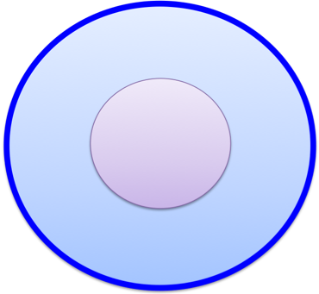

1. What is a convergent boundary? (use a drawing with arrows also).
2. What forms at a convergent boundary (list at least four things)?

**Practice Quiz**

1. Which is thicker?
   1. Oceanic lithosphere
   2. Continental lithosphere
2. What are the inner core and outer core made of?
   1. Molten rock
   2. Solid rock
   3. Iron
   4. Lava
3. Which of the following layers of the earth is NOT made of liquid?
   1. Lithosphere
   2. Mantle
   3. Asthenosphere
   4. Outer Core
4. Which of the following correctly compares the lithosphere and the asthenosphere?
   1. Both are hot, liquid inner layers of earth.
   2. Both are solid, cool layers of earth close to the surface.
   3. The lithosphere is rigid and less dense than the hot and liquid asthenosphere.
   4. The asthenosphere is rigid and less dense than the hot and liquid lithosphere.
5. What is the process called that moves the continents and plates?
   1. Convection
   2. Shape shifting
   3. Magic
   4. Divergence
6. What type of boundary forms a trench?
   1. Convergent Collision
   2. Divergent
   3. Convergent Subduction
   4. Transform
7. What is the term used to describe the motion of molten rock in the mantle?
   1. Conduction Current
   2. Convection Current
   3. Jet Stream Current
   4. Inner Earth Current
8. Which of these gives evidence for the existence of Pangea?
   1. The coastlines of the continents do not fit together.
   2. The continents have remained in place for millions of years.
   3. Fossils of the same animal were found on two different continents.
   4. Fossils of two different animals were found of two different continents.
9. Which distance below could be the distance that a tectonic plate might move in one year?
   1. It could move 5 millimeters
   2. It could move 12 meters
   3. It could move 5 centimeters
   4. It could move 12 kilometers