Name:

Test – Weather

Version: A

- Using the pictures of the gas samples below, which of the following is most likely to be true? (4c)
A | B

  - Gas A has a higher temperature than Gas B
  - Gas A has a lower density than Gas B
  - Gas A has a higher atmospheric pressure than Gas B
  - Gas A will float and Gas B will sink

- Write the temperature of the thermometer to the right in degrees Fahrenheit. (4c)

- Which of the following choices describes an air mass over Mississippi in Summer? (4c)
  - Cool and dry
  - Cool and wet
  - Warm and dry
  - Warm and wet

- An air mass is described as maritime tropical, what is probably true about this air mass? (4c)
  - It is found over land and has a high temperature.
  - It is found over land and has a low temperature.
  - It is found over water and has a high temperature.
  - It is found over water and has a low temperature.

- What is convection? (4c)
  - Movement of air and water because of differences in temperature
  - The curving of wind because of Earth’s rotation
  - A fast moving wind that goes from west to east
  - A large body of air with similar temperature and moisture

- What causes wind? (4c)
  - Evaporation of water
  - Air masses
  - Fronts
  - Differences in temperature

- A cold air mass is moving down through Jackson bringing heavy rain and thunderstorms. What is this called? (4c)

  - A warm front
  - A cold front
  - A stationary front
  - A occluded front

- What is it called when a warm air mass moves in bringing light rain and warm temperatures? (4c)
  - A warm front
  - A cold front
  - A stationary front
  - A occluded front

- Which of the following are the effects of a stationary front? (4h)
  - Cooler weather and rain or snow
  - Drizzly rain then warm weather
  - Clear skies then rain
  - Light rain and wind

- When a warm air mass takes over a cold air mass and causes light rain and wind this type of front occurs: (4h)
  - Warm front
  - Stationary front
  - Cold front
  - Occluded front

- The weatherman predicts that tomorrow a cold front will move in over Jackson, MS. What should the weatherman predict the weather would be? (4h)
  - Cooler weather and lots of rain or snow
  - Drizzly rain then warm and clear conditions
  - Clear skies then heavy rain and warm weather
  - Cooler weather and thunderstorms, heavy rain, or snow

- The following maps show a front as it moves east across the United States.
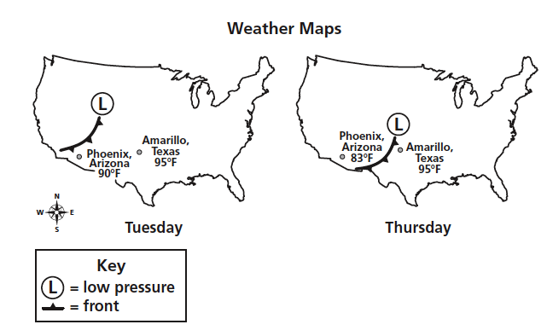

Which of these describe the weather change that can be expected in Amarillo, Texas? (4h)
  - The cold front will bring cooler temperatures and snow.
  - The cold front will bring cooler temperatures with thunderstorms and rain.
  - The warm front will bring warmer temperatures with hot air for several days.
  - The warm front will bring warmer temperatures with light rain for a few days.
Use the map below to answer questions 13-15.

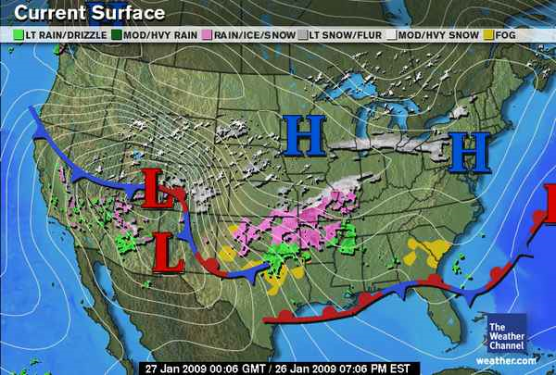

- What kind of pressure is located over the Northeastern United States? (4h)
  - Low pressure
  - High pressure
  - Heavy pressure
  - Light front

- What kind of weather should the Northeastern United States expect? (4h)
  - Nice weather
  - Thunderstorms
  - Heavy rain
  - Hail

- What kind of front is moving toward Louisiana and Mississippi? (4h)
  - Cold front
  - Warm front
  - Stationary front
  - Occluded front

- What is the name of the process where the clouds become saturated with water causing it to fall from the sky? (4c)
  - Condensation
  - Precipitation
  - Evaporation
  - Collection
- What kind of cloud predicts nice weather?
  - Nimbus
  - Cumulonimbus
  - Cumulus
  - Stratus
- If the forecast for tomorrow was thunderstorms and heavy rain and possible snow, what do you think the clouds you see that day would be?
  - Nimbostratus
  - Cirrus
  - Stratus
  - Cumulonimbus
Cirrus clouds
- Which two types of clouds are Both good predictors of precipitation?
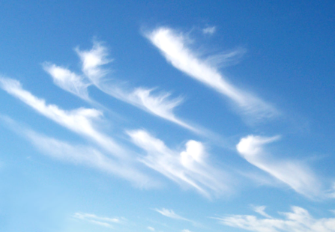
  - Cirrus and Cumulus
  - Stratus and Cumulus
  - Nimbostratus and Cumulonimbus
  - Cumulus and Nimbus
- Where are Cirrus clouds (like the ones to the right) found in the atmosphere?
  - High
  - Low to the ground
  - In the middle
- What kind of weather do you think the clouds on the right would predict?
  - Nice sunny weather
  - Stormy weather
  - Snow
  - Rain

