Key Points on Photosynthesis:
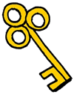
- Autotroph: an organism which use the suns energy directly to produce sugars (producers)
- Heterotroph: an organism which gets the suns energy indirectly by eating other organisms with stored energy (consumers)
- Photosynthesis is a chemical reaction that occurs in autotrophs, producing sugars for energy
  - Happens in the chloroplast with the help of chlorophyll
  - Happens in a series of steps
    - Water (H₂O) and Carbon Dioxide (CO₂) enter the autotroph cells
    - They combine with solar energy (energy from sunlight)
    - Oxygen (O₂) is produced and released into the atmosphere
    - Sugar, also called glucose (C₆H₁₂O₆) is produced and used in the plant
Key Points on Cellular Respiration:
- Both autotrophs and heterotrophs perform cellular respiration.
- Cellular respiration is a chemical reaction that converts food into cellular energy (ATP)
  - Happens in the mitochondria. The many membrane surfaces in the mitochondria make provide a large surface area for cellular respiration to occur
  - Happens in a series of steps:
    - Glucose (C₆H₁₂O₆) combines with oxygen (O₂) in a cell through a process called oxidation.
    - Carbon dioxide (CO₂) is produced and released into the atmosphere.
    - Water (H₂O) is produced and released into the atmosphere.
    - ATP is produced and used as the cell’s form of energy.
Key Points on Sexual vs. Asexual Reproduction:
- Reproduction is the process of making more of one’s own kind
- Sexual reproduction requires two parents and produces organisms with a combination of DNA from each parent.
- Asexual reproduction requires only one parent and produces organisms with DNA that is identical to the parent’s DNA.
- Somatic cells are body cells (examples: blood cells or skin cells)
  - Have the full number of chromosomes for an organism
  - Used in asexual reproduction
- Gametes are sex cells (examples: sperm cells or egg cells)
  - Have half the number of chromosomes as a body cell
  - Used in sexual reproduction
- Human somatic (body) cells have 46 chromosomes. Human gametes (sex cells) have only 23 chromosomes. When a sperm cell and an egg cell combine they form a zygote with 46 chromosomes. This zygote will grow into a baby.
Sexual vs. Asexual Reproduction: Guided Reading (Low, Med, High)
The process of making more of one’s own kind is called reproduction. Each species, or kind, of organism reproduces only its own kind. So, green mold makes only green mold, octopuses make only octopuses, and humans make only humans. Reproduction is essential for the survival of a species.
Many organisms reproduce by combining cells from two different parents. This type of reproduction is called sexual reproduction. In sexual reproduction, the offspring receive genetic material from both parents.
Some organisms can reproduce independently. This type of a reproduction is called asexual reproduction. The prefix “a” means “non.” Organisms made through asexual reproduction will have only one parent, and their genetic information will be identical to their parent.
There are two types of cells in your body, somatic cells and gametes. Somatic cells are normal body cells, like the cells that make up your eyes, elbows, and bones. These cells have the full number of chromosomes. Organisms that reproduce asexually divide somatic cells in mitosis. Gametes are sex cells. Organisms that reproduce sexually combine gamete cells. Gamete cells have half the number of chromosomes as normal cells, so when the two parent cells combine, the new organism has the full number or chromosomes.
Key Points on Homeostasis:
- Homeostasis is the maintenance of stable internal environments in the body
All living things respond to their environment to maintain homeostasis
Name: _______________________________________________ Date: _________________ Class: ____

Unit 4 Review Sheet: Test Tomorrow (Tuesday, December 6th)

4.1: Cell Theory
- Which type of cell has a nucleus, prokaryote or eukaryote? _________________________________
- Which type of cell has membrane bound organelles, prokaryote or eukaryote? ______________
- Which type of cell is larger, prokaryote or eukaryote? _______________________________________
- Which type of cell makes up plants and animals, prokaryote or eukaryote? __________________
- Which type of cell is a bacterial cell, prokaryote or eukaryote? ______________________________
- A student is looking through a microscope at a bacterial cell. The DNA of the bacteria floats in the cytoplasm of the cell, and there are no membrane bound organelles. Explain which type of cell the student is observing, AND explain how you know you are correct.

4.2: Cellular Organization
- When a specific function is carried out by a group of tissues that work together, whose tissues come together to form what? __________________________________________
- Similar CELLS work together to make up the lining of human’s stomach. The stomach lining is an example of what? __________________________________________
- Your eyes, your brain, and other organs work together to form what? ________________________
- Red blood cells and write blood cells work together to form what? ___________________________
- The glands that produce digestive fluids, the mucus producing tissue lining the stomach, and muscle tissue help make up? __________________________________________
- Your mouth, esophagus, stomach, and intestines come together to form what? ______________
- The eye is considered an organ, who best explains why this is true? (Circle your answer).

Gucci Says…Because it is made up of different tissues working together.

Boosie Says…Because it requires light energy to function correctly

Nicki Says…Because it is almost completely surrounded by bones.

- Who correctly organized the levels from simplest to most complex? (Circle your answer).

Gucci Says… Organism organ system organ tissue cell

Boosie Says… Tissue cell organ system organism organ

Nicki Says… cell tissue organ organ system organism

4.3 & 4.4: Organelles
**Use the crossword puzzle at the end of the packet to help you review this. You must know the structure and function of each organelle we discussed in class.

4.5: Photosynthesis
- What is the difference between an autotroph and a heterotroph?

- One example of an autotroph is ___________________________________________________________.
- One example of a heterotroph is __________________________________________________________.
- In which organelle does photosynthesis occur? ____________________ Write the chemical formula for photosynthesis in the space below. Label the reactants and products.

- There are two products that are made in photosynthesis. Which one is most useful to the plant, and which one does it give off as a waste product? Why is this waste product useful to animals?

4.6: Cellular Respiration
- Which types of organisms do cellular respiration?
- In which organelle does respiration occur? ____________________ Write the chemical formula for photosynthesis in the space below. Label the reactants and products.

- For the questions below, tell if the statement applies to photosynthesis (P), cellular respiration (CR), or both (B).

_____ Only occurs in autotrophs

_____ Oxidizes glucose to make energy

_____ Happens in the chloroplast

_____ Uses carbon dioxide, water, and sunlight to make sugar

_____ A process that makes glucose for plant cells and some protists

_____ Uses solar energy (sunlight) as a reactant

_____ Happens in the mitochondria

_____ Occurs in both autotrophs and heterotrophs

_____ Have glucose and oxygen somewhere in the chemical equation

_____ A process that uses glucose to produce ATP

_____ Can happen without sunlight

_____ Oxygen is a reactant

_____ Gives off carbon dioxide as a waste product

_____ ATP is a product

4.7: Compare/Contrast Plant and Animal Cells
- In which type of cells does photosynthesis occur, plant or animal? ___________________________
- In which type of cells does cellular respiration occur, plant or animal? ________________________
- Which three structures are found in plant cells but not in animal cells?

- Compare/contrast the overall shape of plant and animal cells.

4.8: Mitosis
- What are the overall functions of the cell cycle?
- The part of the cell cycle that happens before mitosis is called ________________________. What is occurring within the cell during this part of the cell cycle?

- Fill in the table below to describe what happens to the chromosomes (DNA/genetic information) during each phase of mitosis:
Prophase | Metaphase | Anaphase | Telophase

- The part of the cell cycle that happens after mitosis is called ________________________. What is occurring within the cell during this part of the cell cycle?

4.9 & 4.10: Reproduction & Cell Types & Meiosis
- Sexual requires ________ parent(s), asexual requires ________ parent(s).
- Compare and contrast how offspring get their DNA in sexual and asexual reproduction.
- Fill in the table below about types of cells!
 | Scientific Name | Half the number of chromosomes or full number? | Haploid cell or diploid cell? | Examples: | Made is mitosis or meiosis?
Sex Cells
Body Cells

- A species of a male chipmunk has 20 chromosomes in its sperm cell and mates with a female chipmunk who has 20 chromosomes in its egg cell. How many chromosomes will be found in the somatic cells of its offspring?

- A species of lizard has 28 chromosomes in each somatic cell. How many chromosomes would be found in a gamete of a female lizard?

4.11: Homeostasis
- What does the word homeostasis mean?

- Explain how our body works to maintain temperature homeostasis.
Crossword Puzzle: Organelles
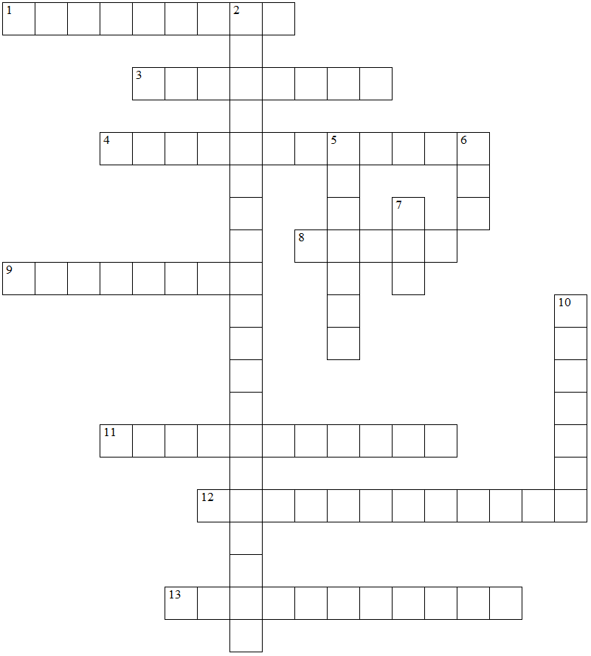

ACROSS  1 This organelle allows organelles to float within the cell and move more easily.  3 This is a strong and protective barrier found only in plant cells.  4 This organelle is the site of cellular respiration, it uses food molecules to make energy.  8 Chloroplasts, cell walls, and large central vacuoles are only found in these types of cells.  9 This organelle is responsible for synthesizing (making) proteins.  11 The substance in chloroplasts that help them to absorb sunlight.  12 This organelle controls what enters and exits the cell, also known as the security guard  13 This organelle uses energy from sunlight to produce sugars for plants. | DOWN  2 The term that means only certain substances may pass through a barrier.  5 This organelle controls all of the cellular processes.  6 The mitochondria produce this chemical compound during respiration.  7 This important molecule is found inside the nucleus of eukaryotic cells.  10 This organelle is found mainly in plants and is used for storing water and other substances.

