6th Grade Science | Name
Plate Tectonics: MS 4a,b | Date Block

Directions: Answer these questions to the best of your ability. WRITE on this test. Record all of your answers on your answer sheet.

- Using the image at the right, which of these describes the layer of Earth’s structure shown at #1?
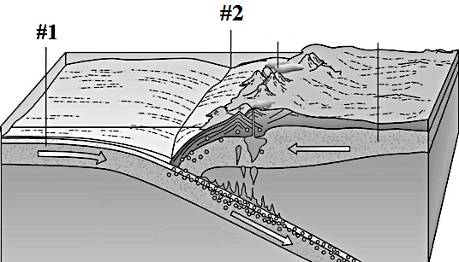
  - Continental crust is shown at #1.
  - Oceanic crust is shown at #1.
  - Asthenosphere is shown at #1.
  - Continental lithosphere is shown at #1.

- Using the image at the right, which of these describes the landform shown at #2.
  - A mid ocean ridge forming at a subduction zone is shown at #2.
  - A mid ocean ridge forming at a divergent boundary is shown at #2.
  - A trench forming at a subduction zone is shown at #2.
  - A trench forming at a divergent boundary is shown at #2.

- How does the temperature change as you go from the surface toward the center of Earth?
  - It increases
  - It decreases
  - It stays the same
  - It increases then decreases

- Which of the following is a location where oceanic crust would be found?
  - A mountain range in the middle of the North American plate.
  - The Amazon River in South America.
  - The Marianna Trench in the Pacific ocean.
  - The Great Rift Valley in the African countries of Kenya and Tanzania.

- Which is most true about Earth’s outer core?
    - It is under low pressure
    - It is at low temperature
    - It liquid.
    - It is made of magnesium.

- Which of these defines a convection current that forms in the asthenosphere?
  - Plastic-like material near the core is cooler than the surrounding material causing it to be more dense and rise where it is reheated.
  - Plastic-like material near the core is cooler than the surrounding material causing it to be less dense and rise where it is reheated.
  - Plastic-like material near the core is hotter than the surrounding material causing it to be more dense and rise where it is cooled.
  - Plastic-like material near the core is hotter than the surrounding material causing it to be less dense and rise where it is cooled.

- Which of these describes the lithosphere and the asthenosphere?
  - The lithosphere is brittle and solid, and the asthenosphere is hot and flowing.
  - The asthenosphere is brittle and solid, and the lithosphere is hot and flowing.
  - Both are hot inner layers of earth capable of bending and flowing.
  - Both are solid and brittle layers of earth close to the surface.

- The Mid Atlantic Ridge is a mid ocean ridge found on the floor of the Atlantic Ocean. Which of these explains what is causing this mid ocean ridge to form?
  - Two tectonic plates are moving together because of a convection current.
  - Two tectonic plates are moving apart because of a convection current.
  - Two tectonic plates are moving together because of an ocean current.
  - Two tectonic plates are moving apart because of an ocean current.

- Which of these explains what will occur at the subduction boundary between the more dense Pacific plate and less dense Philippine plate?
  - The Pacific Plate will rise above the Philippine Plate. The Philippine Plate will sink into the mantle and melt.
  - The Pacific Plate will sink below the Philippine Plate. The Pacific Plate will sink into the mantle and melt.
  - The Pacific Plate and the Philippine Plate will collide forming a mountain range.
  - The direction the Pacific and Philippine Plates will travel is not possible to determine using this information.
- Two plates composed of crusts of the same density meet along a convergent boundary. Which statement describes what will happen where the two plates meet?
  - The plates will rub against each other.
  - The plates will collide with neither plate subducting, causing the crust to pile up and form a mountain range.
  - The plates will collide and form a rift valley.
  - The plates will rub against each other, causing one plate to subduct underneath the other plate and forming a deep trench along the boundary.

- Which statement below describes how the surface of the Earth has changed over the last 200 million years?
  - The Earth’s tectonic plates have moved a few centimeters a year, but the surface of the Earth still looks the same as it did 200 million years ago.
  - The Earth’s tectonic plates have moved a few centimeters a year, causing the continents to change location a lot.
  - The Earth’s tectonic plates have moved a few miles a year, but not enough to change the surface of the Earth dramatically.
  - The Earth’s tectonic plates have moved a few miles a year, causing the continents to dramatically change location.

- Scientists often describe Pangea and the impact that Plate Tectonics had on it. Which of these describes Pangea?
  - The theory that the continents are moving closer together.
  - The theory that the continents were once all underwater.
  - The theory that the continents were once all connected.
  - The theory that the continents never move.

- Though the idea of Pangea is considered a theory, there is a large amount of evidence supporting it. Which of these is NOT a reason that scientists believe Pangea existed?
  - Fossils of the reptile Mesosaurus have been found in both South America and Africa.
  - The eastern coast of South America and the western coast of Africa have a similar shape.
  - Fossils of the tree Sequoia were found in North America and fossils of a different tree Adasonia have been found in Africa.
  - Fossils of the flower Glossopteris have been found in both India and Australia.

- Which of these describes a divergent boundary?
  - Two continental plates moving away from each other, forming a rift valley.
  - Two oceanic plates sliding against each other, forming a midocean ridge.
  - Two continental plates colliding, forming a mountain range.
  - Two oceanic plates colliding, forming a volcanic arc.

- Which of these describes a transform boundary and the effect that is often seen there?
  - Two tectonic plates are sliding past one another creating faults, conditions that often cause earthquakes.
  - Two tectonic plates are sliding past one another creating trenches, conditions that often cause oceans to form.
  - Two tectonic plates are colliding with one another creating subduction zones, conditions that often cause volcanoes to form.
  - Two tectonic plates are sliding past one another creating subduction zones, conditions that often cause trenches to form.

- About 30 miles into Earth, the speed of seismic waves increases. What does this change in speed tell you about the material through which the seismic waves are traveling?
  - The waves travel from rock into metal material.
  - The waves travel from cool material into hot material.
  - The waves travel from solid material into liquid material.
  - The waves travel from a less dense material into a more dense material.

- A scientist is studying a new volcano that has formed. She has made the following observations regarding the volcano.
- Erupts lava, ash, and cinders.
- Steep sides
- Sharply pointed peak
Which of these is most likely true?
  - It is a cinder cone volcano found in the Pacific Ring of Fire.
  - It is a composite volcano found in the Pacific Ring of Fire.
  - It is a cinder cone volcano found over a transform boundary.
  - It is a composite volcano found over a transform boundary.

- A layer of solid brittle rock makes up the outer 100 kilometers of Earth. This layer, which contains the crust, is called the
  - Core
  - Sediment
  - Lithosphere
  - Hemisphere

- Which of the following Earth layers is solid?
  - Asthenosphere
  - Mantle
  - Inner core
  - Outer core

- Which of the following graphs BEST represents the relationship between density and depth of material below Earth’s surface?
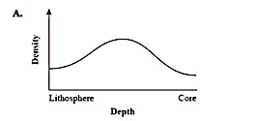 | 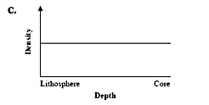
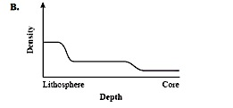 | 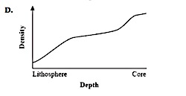

- The following diagram shows the motion of two plates.
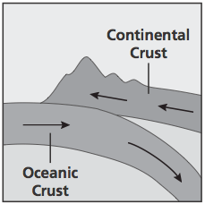
Which of the following explains the feature that can form at the boundary of these two plates?
- A broad canyon-like valley because the two colliding plates act like a plow, digging out any soil in the plates’ paths
- Volcanic mountain range because one oceanic plate melts underneath the continental plate, forming composite volcanoes on the continent
- A hotspot because one oceanic plate melts underneath the continental plate, forming volcanic mountains that eventually become islands
- Folded mountain range because the two colliding plates have equal composition and density, causing both to fold and form wide, thick mountains

The diagram below shows four layers of the Earth. Each layer is identified by a number. Use this diagram to answer questions 25-29.
- Which layer of Earth is made up of solid iron?
  - Layer 1
  - Layer 2
  - Layer 3
  - Layer 4

- Label each of the four layers of the Earth (1-4) shown in the diagram.
1 = _____________
2 = _____________
3 = _____________
4 = _____________

- Write one thing that describes what layer 1 is made of.

- Write one thing that describes what layer 2 is made of.

- How does layer 2 control the movements of layer 1?

- What is shown in the image below?
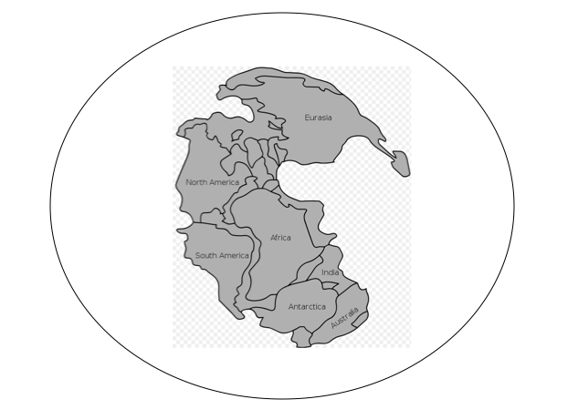
BONUS!!! Make a prediction. If you were able to travel 200 million years in the future, would the continents look different than they do today? To receive extra credit you MUST explain your answer using full sentences.

