In class worksheet  Plant and Animal Cells  1. What are three things that plant cells have that animal cells do not?  2. What organelle allows plants to make their own food?  3. What is the function of the cell wall?  4. Is this a picture of a plant or animal cell?  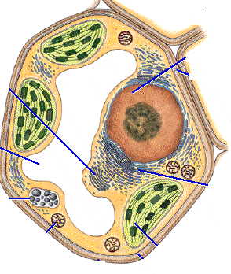 | Homework  1. List some structures that BOTH plant and animal cells have:  2. Which of the following structures are found in plant cells but not animal cells?  a. golgi apparatus  b. nucleus  c. chloroplast  d. cell membrane  3. What structure unique to plant cells allows plants to make their own food?  a. endoplasmic reticulum  b. cell wall  c. cell membrane  d. chloroplast  4. A scientist is looking at a cell under a microscope. The cell one large vacuole has. What type of cell is she most likely looking at?  5. Look at the picture below. Is it a plant or animal cell? How do you know?  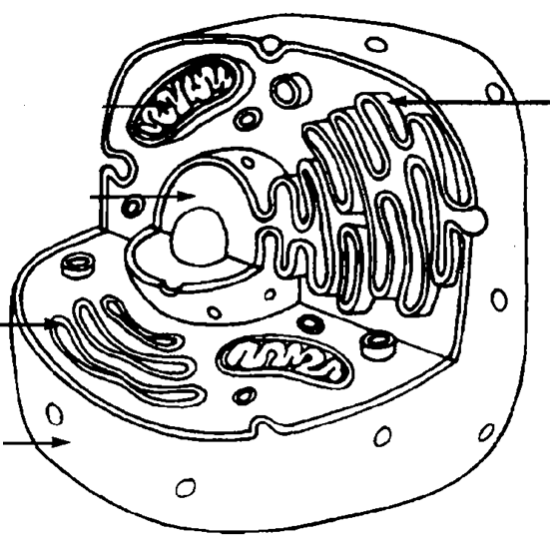  6. A scientist is looking at a cell under a microscope. The cell has both a cell membrane and a cell wall. Is the scientist looking at a plant or an animal cell?  7. What is the function of the nucleus?
OBJECTIVE.  What is your objective? ⇨ | KEY POINTS.  What knowledge and skills are embedded in the objective? ⇨
SWBAT state the differences between plant and animal cells as plant cells have cell walls, large central vacuoles and chloroplast organelles, while animal cells do not | - Plant and animal cells share most of their organelles  - Plants have a few extra structures in their cells  - These structures are the cell wall, large central vacuoles, and chloroplast  - The cell wall is on the outside of the cell membrane and helps the cell keep its shape and protects the cell  - The large vacuole in plants also stores food, water, and waste  - The chloroplast are organelles that allow plants to make their own food.

